MD2201: Data Science

Name of the student: SUMIT UMBARE Roll No. 77

Div: IT-B Batch: B3

Date of performance: 16/02/2024

Experiment No.2

Title: Laboratory on Statistics
Aim: To find the probability for Binomial distribution and Normal distribution and verify the Normal approximation of Binomial distribution.

Software used: Programming language R.

Code Statement:
Write a single R code to answer the following questions.

Data Set: Travelled Abroad

- Find out the % of Indians in the sample who have travelled abroad using the data source.
- Treating this value as ‘p’, calculate the following probabilities –
  - What is the probability that in a randomly chosen sample of 10 persons, no one has travelled abroad?
  - What is the probability that in a randomly chosen sample of 10 persons, exactly one has travelled abroad?
  - What is the probability that in a randomly chosen sample of 10 persons, exactly two persons have travelled abroad?
  - What is the probability that in a randomly chosen sample of 10 persons, exactly three persons have travelled abroad?
  - What is the probability that in a randomly chosen sample of 10 persons, exactly four persons have travelled abroad?
  - What is the probability that in a randomly chosen sample of 10 persons, exactly five persons have travelled abroad.
  - What is the probability that in a randomly chosen sample of 10 persons, exactly six persons have travelled abroad?
  - What is the probability that in a randomly chosen sample of 10 persons, exactly seven persons have travelled abroad?
  - What is the probability that in a randomly chosen sample of 10 persons, exactly eight persons have travelled abroad?
  - What is the probability that in a randomly chosen sample of 10 persons, exactly nine persons have travelled abroad?
  - What is the probability that in a randomly chosen sample of 10 persons, all 10 persons have travelled abroad?
- Plot the probability values as a Table / Bar graph/plot and interpret plot.

- What is the probability that in the randomly chosen sample of 100 persons at least 59 have travelled abroad?
Hint: Expected to perform Normal approximation for the binary distribution.

Code:

g<-read.csv("travelled abroad_csv.csv")
traveeled<-nrow(subset(g,Travelledabroad=="Y"))
percentage<-traveeled*100/nrow(g)
cat("Percentage of pepople travelled abroad ",percentage)

p=percentage/100
cat("\nProbablity of success ",p)

d<-dbinom(0:10,10,p)
cat("\nProbability that in a randomly chosen sample of 10 persons, no one has traveled abroad:", d, "\n")

plot(0:10,d,type="l")

d2<-sum(dbinom(59:100,100,p))
d3<-dbinom(0:100,100,p)
plot(0:100,d3,type="l")

cat("Probablity of binomial distribution with n=100 ",d2)

m<-100*p
cat("\nMean is ",m)
sd<-sqrt(100*p*(1-p))
cat("\nStandard deviation is ",sd)
norm<-pnorm(59,m,sd,lower.tail = F)
cat("\nProbabliy of Normal distribution with N=100 ",norm)

Results: Display the output obtained on R console for all the cases. Also add the plots which you obtained. Give proper title to the plots as per the condition.

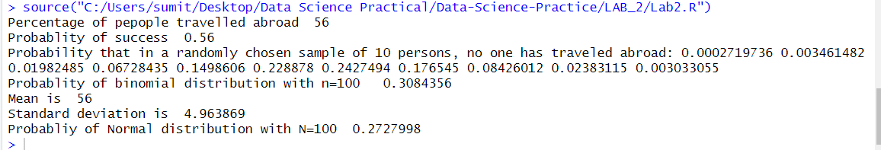

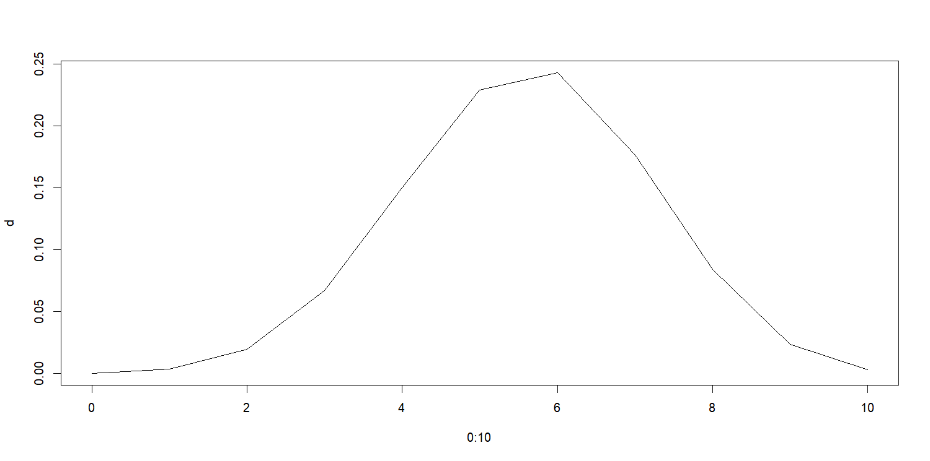

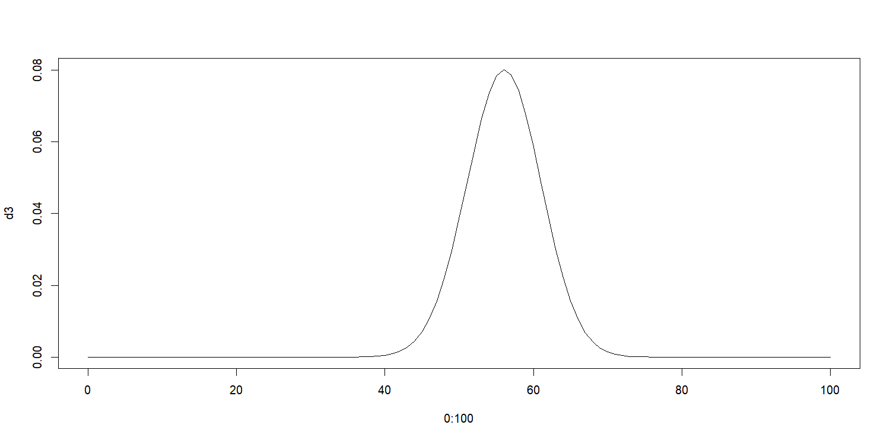

Conclusion:

